**Special Topics: Working with Robots:**

**Business Innovation Using Generative AI**

**MASY1-GC 5000| 100 | Fall 2024 | 9/3/2024 - 12/12/2024 | 3 Credits**

**Modality:** In-Person

**Course Site URL:** <https://brightspace.nyu.edu>

**General Course Information**

**Name/Title:** Dr. Andres Fortino, Clinical Associate Professor, He/Him/His

**NYU Email:** agf249@nyu.edu

**Class Meeting Schedule:** 9/3/2024 - 12/12/2024 | Wednesday | 06:20 pm – 08:55 pm

**Class Location:** In person, 20 W 42 St Campus – Midtown Center – Room 1022

**Office Hours:** Tuesdays, 5:00-6:00 PM, by appointment only. If you would like to schedule a meeting, please send an email to the instructor at least two days prior to the date you would like to meet.

**Description**

This course will explore the application of Generative AI technology to business processes. The course will focus on understanding the technology and its capabilities, as well as how it can be used to improve various aspects of a business. Students will learn about automation, process optimization, data analysis, and decision-making and will have the opportunity to apply their knowledge through hands-on projects and case studies. The course focuses on practical skills, advanced analytic techniques, and strategic thinking essential for leading AI-powered business transformations. Participants will master sophisticated, prompt engineering methods tailored to specific analytical domains. The course will also cover the ethical and societal implications of implementing Generative AI technology in organizations. By the end of the course, students will have a strong understanding of how to implement and integrate generative AI technology into their organizations effectively and to drive innovation and growth. *This course prepares students for the role of business transformation analysts based on Generative AI tools*.

**Prerequisites:** Completion of MASY Core classes

**Learning Outcomes**

At the conclusion of this course, students will be able to:

* Use basic GenAI Large Language Models competently
* Discover a business area for effective application of GenAI
* Apply GenAI tools and techniques to reengineer business processes
* Categorize proposals to reengineer processes using GenAI as to their feasibility and effectiveness
* Create a Proof of Concept (PoC) proposal for reengineering a business process using Generative AI

**Communication Methods**

Be sure to turn on your [NYU Brightspace notifications](https://www.nyu.edu/servicelink/KB0018507) and frequently check the “Announcements” section of the course site. This will be the primary method I use to communicate information critical to your success in the course. To contact me, send me an email. I will respond within 24 hours. Credit students must use their NYU email to communicate. NYU Brightspace LMS course-mail supports student privacy and FERPA guidelines.

The instructor’s email address is [agf249@nyu.edu](mailto:agf249@nyu.edu) and it is checked regularly and frequently; students will usually receive a reply within 12 hours during the workweek. The instructor does not have access to an NYU telephone number.

The instructor will conduct office hours using Zoom, by telephone, or in-person at the NYU campus—by appointment. If you would like to schedule a meeting, please send an email to the instructor at least two days prior to the date you would like to meet. You should also suggest an alternative date in case the first date is not available. Discussions through online platforms will require that you have speakers and a microphone. A video camera is highly recommended.

**Structure | Method | Modality**

There are 14 session topics in this course. The session topics are organized into three (3) areas of study: 1) Learning Principles, 2) Demonstrations, and 3) Practice.

Active learning experiences and small group projects are key components of the course. Assignments, papers, and exams will be based on course materials, lectures, and class discussions. Course sessions will be conducted synchronously on NYU Zoom, which you can access from the course site in [NYU Brightspace](https://brightspace.nyu.edu/).

**Expectations**

Learning Environment

You play an important role in creating and sustaining an intellectually rigorous and inclusive classroom culture. Respectful engagement, diverse thinking, and our lived experiences are central to this course, and enrich our learning community.

Participation

You are integral to the learning experience in this class. Be prepared to actively contribute to class activities, group discussions, and work outside of class.

Assignments and Deadlines

Please submit all assignments to the appropriate section of the course site in [NYU Brightspace](https://brightspace.nyu.edu/). If you require assistance, please contact me BEFORE the due date. See individual deadlines for each type of assignment. See the Greeting/Assessment section below for due dates and lateness penalties.

Course Technology Use

We will utilize multiple technologies to achieve the course goals. I expect you to use technology in ways that enhance the learning environment for all students.

The Use of AI

You are expected to use Generative AI tools (ChatGPT, Claude, and code generation tools such as Code Interpreter) appropriately in this class. In fact, some assignments will require it. Learning to use Al is an emerging skill, and I provide tutorials on how to use them. I am happy to meet and help with these tools during office hours or after class.

Be aware of the limits of Generative AI tools:

* If you provide minimum effort prompts, you will get low-quality results. You will need to refine your prompts in order to get good outcomes. This takes work.
* Don't trust anything it says. If it gives you a number or a fact, assume it is wrong unless you either know the answer or can check in with another source. You will be responsible for any errors or omissions provided by the tool. It works best for topics you understand.
* AI is a tool, but one that you need to acknowledge using. *Please include a paragraph at the end of any assignment that uses AI explaining what you used the Al for and what prompts you used to get the results. Please do so in compliance with academic honesty policies.*
* Be thoughtful about when this tool is useful. Only use it if it is appropriate for the case or circumstance.
* Be aware that the tool often answers precisely the same response to similar problems. So if you and another student asked the same question, you might get exactly the same answer. And if you use that answer as is in your assignment, you will be penalized for plagiarism of another student's response.
* You are responsible for your ethical use of this tool.

Feedback and Viewing Grades

I will provide timely meaningful feedback on all your work via our course site in NYU Brightspace. You can access your grades on the course site Gradebook.

Attendance

I expect you to attend all class sessions. Attendance will be taken into consideration when determining your final grade.

Refer to the [SPS Policies and Procedures page](https://www.sps.nyu.edu/homepage/student-experience/policies-and-procedures.html) for additional information about attendance.

**Textbooks and Course Materials**

**Required**:

* Harvard Business School Publishing Case Study Coursepack (12 cases): <https://hbsp.harvard.edu/import/1072146>. Every student in the class must purchase a copy of these cases. (There will be a 5% penalty in the course grade for no purchase.)

**Recommended:**

* Agrawal, A., Gans, J., & Goldfarb, A. (2018). *Prediction machines: the simple economics of artificial intelligence*. Harvard Business Press.
* Blackman, R. (2022). *Ethical machines: your concise guide to totally unbiased, transparent, and respectful AI*. ‎ Harvard Business Review Press.
* Fortino, A. (2023). *Data Mining and Predictive Analytics for Business Decisions: A Case Study Approach*. Stylus Publishing, LLC.

**SOFTWARE**

**Required**

Open AI ChatGPT- 4o - <https://openai.com/>

Anthropic Claude 3.5 Sonnet - <https://www.anthropic.com/index/claude-2>

Additional open-source programs will be required and installed as instructed in class.

**Grading | Assessment**

Your grade in this course is based on your performance on multiple activities and assignments. Since all graded assignments are related directly to course objectives and learning outcomes, failure to complete any assignment will result in an unsatisfactory course grade. All written assignments are to be completed using APA format and must be typed and double-spaced. Grammar, punctuation, and spelling will be considered in grading. Please carefully proofread your written assignments before submitting them for a grade. I will update the grades on the course site each time a grading session has been completed— typically three (3) days following the completion of an activity.

DESCRIPTION PERCENTAGE

Weekly Review Quizzes 10%

Team In-Class Hands-on Workshops 10%

Homework Assignment - Labs 55%

Team Project 25%

__________________ ____

TOTAL POSSIBLE 100%

See the [“Grades” section of Academic Policies](https://www.sps.nyu.edu/homepage/student-experience/policies-and-procedures.html#Graduate1) for the complete grading policy, including the letter grade conversion and the criteria for a grade of incomplete, taking a course on a pass/fail basis, and withdrawing from a course.

**Final Assignment** – (20%). There will be one final assignment in the form of a team Application of GenAI Project deliverable to ensure that the student has mastered the material presented. Instructions for the assignment are posted on the class website. The final assignment is due on the last day of the semester and will not be accepted late.

Team Case Study 25%

Part A – Proposal 5%

Part B – Final Report 20%

**Homework Assignment Labs** – (55% total, 5% each) best 11 required out of 12 lab assignments. There is a lab due every week. The lowest of all 12 assignment grades will be dropped. Student answers to the labs must be entered in the appropriate Assignment in the Brightspace class website. They are due one week after each class. There is a 20% penalty for a late assignment posting for up to one week late, and a 50% penalty will be given for a lab assignment delivered after the late period until the last day of the semester.

Lab 1 - Discover a business area to develop expertise 5%

Lab 2 - Feasibility of a reengineering PoC proposal 5%

Lab 3 - Prompts for a PoC process 5%

Lab 4 - GenAI to analyze and make decisions on a dataset 5%

Lab 5 - GenAI to analyze text-based data 5%

Lab 6 - GenAI to create a WBS and Gantt Chart 5%

Lab 7 - GenAI to analyze a Buy vs. Lease decision 5%

Lab 8 - Gen AI to analyze risk for a business case 5%

Lab 9 - Creating a virtual persona to match IRL person 5%

Lab 10 - Automating user interaction by building a chatbot 5%

Lab 11 - Automating a business process using RPA principles 5%

Lab 12 - PoC proposal 5%

**Team In-Class Hands-on Workshops** – (10% total, 1% each). 10 required out of 12 team workshop deliverables There is a team Hands-on workshop due every week. The top 10 out of 11 lab grades will be retained to contribute to the final grade; the lowest team workshop grade will be dropped. Student answers to the team workshops will be entered in the appropriate Assignment on the Brightspace class website. They are due one day after the class. The assignments are done by the team at the end of each class so there is no need for extra time to complete assignments. No credit will be given for a lab assignment delivered after that.

Team HW 2 - Identifying areas for automation 1%

Team HW 3 - Prompts for brainstorming GenAI application ideas 1%

Team HW 4 - GenAI to analyze and make decisions on a dataset 1%

Team HW 5 - GenAI to analyze text-based data 1%

Team HW 6 - GenAI to create a WBS and Gantt Chart 1%

Team HW 7 - GenAI to analyze financial statements 1%

Team HW 8 - Gen AI to fill out a risk matrix 1%

Team HW 9 - Virtual vs. IRL focus group participants 1%

Team HW 10 - Customer Service Chatbot 1%

Team HW 11 - Automating a business process using RPA 1%

Team HW 12 - Case studies of ethical issues 1%

**Review Quizzes** - (10%). There are 10 out of 12 required REs (Reflection Exercises), 1% each for filling them out; credit is not based on the score. This is not an exercise to measure what you know but to help you transfer knowledge from short-term memory to long-term memory. Students who used these exercises got as much as a 30% increase in their final exam grades in the past. The quizzes are open online for a whole week, and they are timed to maximize knowledge transfer. Students are advised to take each Quiz when it is available. There are no late submissions.

**Course Outline**

**Start/End Dates:** 9/6/2024 - 12/13/2024 | Wednesday

**Time:** 06:20 pm – 08:55 pm

**No Class Date(s):** Wednesday, 11/22/23, Fall Break

**Special Notes:** N/A

**Session 1, 09/03/24**

Week 1: Introduction to Generative AI Technology

* Overview of AI and machine learning
* Types of AI, including generative A
* What are Generative AI and Lange Language Models
* Supervised, unsupervised and reinforced learning machines
* Deep learning and Neural Networks
* Applications of Generative AI in Industries

Team Hands-On Workshop 1: Building a reinforcement learning model

Homework Assignment Lab 1: Discover a business area to develop expertise in to apply GenAI models. Propose a technology adoption project.

Reading: *Harvard Case Study: "Data Is the New Oil" from Prediction Machines: The Simple Economics of Artificial Intelligence*

Technology Reference – Neural Networks from the Ground Up. <https://www.youtube.com/watch?v=aircAruvnKk>

Technology Reference – How Machines Learn. <https://www.youtube.com/watch?v=IHZwWFHWa-w>

**Session 2, 09/10/24**

Week 2: Automation and Process Optimization

* How generative AI can be used to automate business processes
* Business transformation: process reengineering
* Goldman Sacs Reengineering Feasibility Scale
* Case studies of companies using generative AI to optimize processes

Team Hands-On Workshop 2: Identifying potential areas for automation in a business

Homework Assignment Lab 2: Evaluate the feasibility of a reengineering PoC proposal using AI.

Reading: *Harvard Case Study: 6. "The New Division of Labor" from Prediction Machines: The Simple Economics of Artificial Intelligence.*

Reference: Wolfram, S. (2023). *What Is ChatGPT Doing... and Why Does It Work?*. Stephen Wolfram. <https://writings.stephenwolfram.com/2023/02/what-is-chatgpt-doing-and-why-does-it-work/>

Reference: Wang, S., *Using the Robot as a Research Assistant: Research Design Using Generative AI,* Spring MASY 2023 Capstone, Applied Analytics Lab, <http://hdl.handle.net/2451/69528>.

Reference: Chuan, M., *ChatGPT and Generative AI in IT Processes,* Spring MASY 2023 Capstone, Applied Analytics Lab, <http://hdl.handle.net/2451/69530>.

**Session 3, 09/17/24**

Week 3: Prompt Engineering

* Skills building on using Large Language Models effectively
* Creating effective prompts
* Installing and using extensions to the basic models
* Adding personas to focus prompts

Team Hands-On Workshop: Creating a prompt for brainstorming GenAI application ideas

Homework Assignment Lab 3: Creating prompts for a PoC process

**Session 4, 09/24/24**

Week 4: Data Analysis and Decision Making

* How generative AI can be used to analyze data and make decisions
* Case studies of companies using generative AI for data analysis and decision making

Team Hands-On Workshop 4: Using generative AI to analyze and make decisions based on a dataset

Homework Assignment Lab 4: Use GenAI to analyze a data set using machine learning techniques

Reading*: Harvard Case Study: Rocket Fuel- Measuring the Effectiveness of Online Advertising*

Reference: Shou, S., *Implementing Generative AI Tools in Analytics,* Spring MASY 2023 Capstone, Applied Analytics Lab, <https://archive.nyu.edu/handle/2451/69533>.

**Session 5, 10/01/24**

Week 5: Natural Language Processing

* Overview of NLP and its Applications
* How generative AI can be used to improve NLP
* Case studies of companies using generative AI for NLP

Team Hands-On Workshop 5: Using generative AI to analyze text-based data

Homework Assignment Lab 5: Analyze comparing a resume to jobs using a similarity scoring algorithm created by generative AI

Reading: *Harvard Case Study: Understanding Text Mining and Sentiment Analysis in Hotel Booking*

**Session 6, 10/08/24**

Week 6: Generative AI in Project Management

* Overview of the project management and its use of AI
* How generative AI is being used to improve project management
* Case studies of companies using generative AI in PM

Team Hands-On Workshop 6: Using GenAI to create a WBS and Gantt Chart

Homework Assignment Lab 6: Using GenAI to create a WBS and Gantt chart

Reading: Harvard Case Study: Project Management at Kuehchic Desserts- Refreshing A Traditional Business

Reference: Weng, J., *Putting Intellectual Robots to Work: Implementing Generative AI Tools in Project Management,* Spring MASY 2023 Capstone, Applied Analytics Lab, <http://hdl.handle.net/2451/69531>.

Reference: Nieto-Rodriguez A, Viana Vargas R. How AI Will Transform Project Management. *Harvard Business Review Digital Articles*. February 2023:1-10. Accessed July 27, 2023. <https://search-ebscohost-com.proxy.library.nyu.edu/login.aspx?direct=true&db=bth&AN=161930270&site=eds-live>. From the NYU Library.

**Session 7, 10/22/24**

Week 7: Generative AI in Finance

* Overview of the finance industry and its use of AI
* How Generative AI is being Used to improve finance
* Adding finance plugin to ChatGPT
* Case studies of companies using generative AI in finance

Team Hands-On Workshop 7: Using generative AI to analyze financial statements and computer financial ratios

Homework Assignment Lab 7: Analyze a Buy vs. Lease financial decision using generative AI

Reading: *Harvard Case Study:* *Introduction to Financial Ratios and Financial Statement Analysis*

Reading: *Harvard Case Study:* *Technical Note- Lease vs. Buy Decisions for Technology.*

**Session 8, 10/29/24**

Week 8: Generative AI in Risk Management

* Overview of risk management and the use of AI
* Analyzing risk using GenAI
* Case studies of companies using generative AI in HR

Team Hands-On Workshop 8: Filling out a risk matrix for a case study

Homework Assignment Lab 8: Analyzing risk for a business case

Team Project Proposal Due

Reading: *Harvard Case Study: Project Management at Kuehchic Desserts- Refreshing A Traditional Business. HBR Case course pack.*

**Session 9, 11/05/24**

Week 9: Generative AI in Marketing

* Overview of the marketing industry and its use of AI
* How generative AI is being used to improve marketing
* Case studies of companies using generative AI in marketing
* Virtual personas

Team Hands-On Workshop 9: Matching answers to surveys by virtual vs real focus group participants

Homework Assignment Lab 9: Digital Twin- virtual persona vs. IRL person

Reading: *Harvard Case Study*: *Ad-lider Embalagens, SA: Marketing Research for Drawstring Trash Bags in Brazil*

Reading: *Harvard Case Study: Understanding User Needs.*

Reference: Ning, T., *How ChatGPT Would Contribute to Conduct Lean Canvas Model,* Spring MASY 2023 Capstone, Applied Analytics Lab, http://hdl.handle.net/2451/69529.

**Proposal for Team Assignment due**

**Session 10, 11/12/24**

Week 10: Generative AI in Customer Support

* Automating customer/user interactions
* How generative AI can be used to improve the capabilities of customer/user service departments
* Chatbots, what they are and how to build them
* Case studies of companies using generative AI in robotics and automation

Team Hands-On Workshop 10: Create a simple chatbot for customer service

Homework Assignment Lab 10: Automating user interaction by building a chatbot

Reference: Siggelkow, Nicolaj, and Christian Terwiesch. 2023. “Create Winning Customer Experiences with Generative AI.” *Harvard Business Review Digital Articles*, April, 1–7. <https://search-ebscohost-com.proxy.library.nyu.edu/login.aspx?direct=true&db=bth&AN=163006501&site=eds-live.> From the NYU Library.

**Session 11, 11/19/24**

Week 11: Robotics and Automation

* Overview of Robotics and Automation
* RPA - Robotics Process Automation
* How generative AI can be used to improve the capabilities of robots and automation systems
* Case studies of companies using generative AI in robotics and automation

Team Hands-On Workshop 11: Automating a business process using RPA principles

Homework Assignment Lab 11: Automating a business process using RPA principles

Reading: *Harvard Case Study: Artificial Intelligence in Accounting*

**Session 12, 11/26/24**

Week 12: Ethical and Societal Implications

* Overview of the ethical considerations of using generative AI technology
* The societal implications of using generative AI technology, social justice and ML
* Constitutional AI, The Three Laws of Robotics, Government Regulations
* Anthropic Claude 2 vs. OpenAI Chat GTP4 vs. Google Bard.
* Case studies of ethical issues related to generative AI in business

Discussion: Explore the dangers of GenAI in an industry application, applications of The Three Laws of Robotics

Readin*g: Harvard Case Study: "AI Ethics for Developers" from Ethical Machines: Your Concise Guide to Totally Unbiased, Transparent, and Respectful AI*

**Session 13, 12/03/24**

Week 13: Implementing Generative AI in Business

* How to identify and evaluate potential areas for implementing generative AI technology
* Best practices for implementing generative AI technology in business
* Proof of Concept Trials

Team Hands-On Workshop 12: Developing a plan for implementing generative AI technology in a business

Homework Assignment Lab 12: Develop a PoC proposal for reengineering a business process using Gen AI

Reading: *Harvard Business Case: Prototyping: A Quick Introduction.*

**Session 14, 12/10/24**

Final Project Presentations

**Team Project Reports Due**

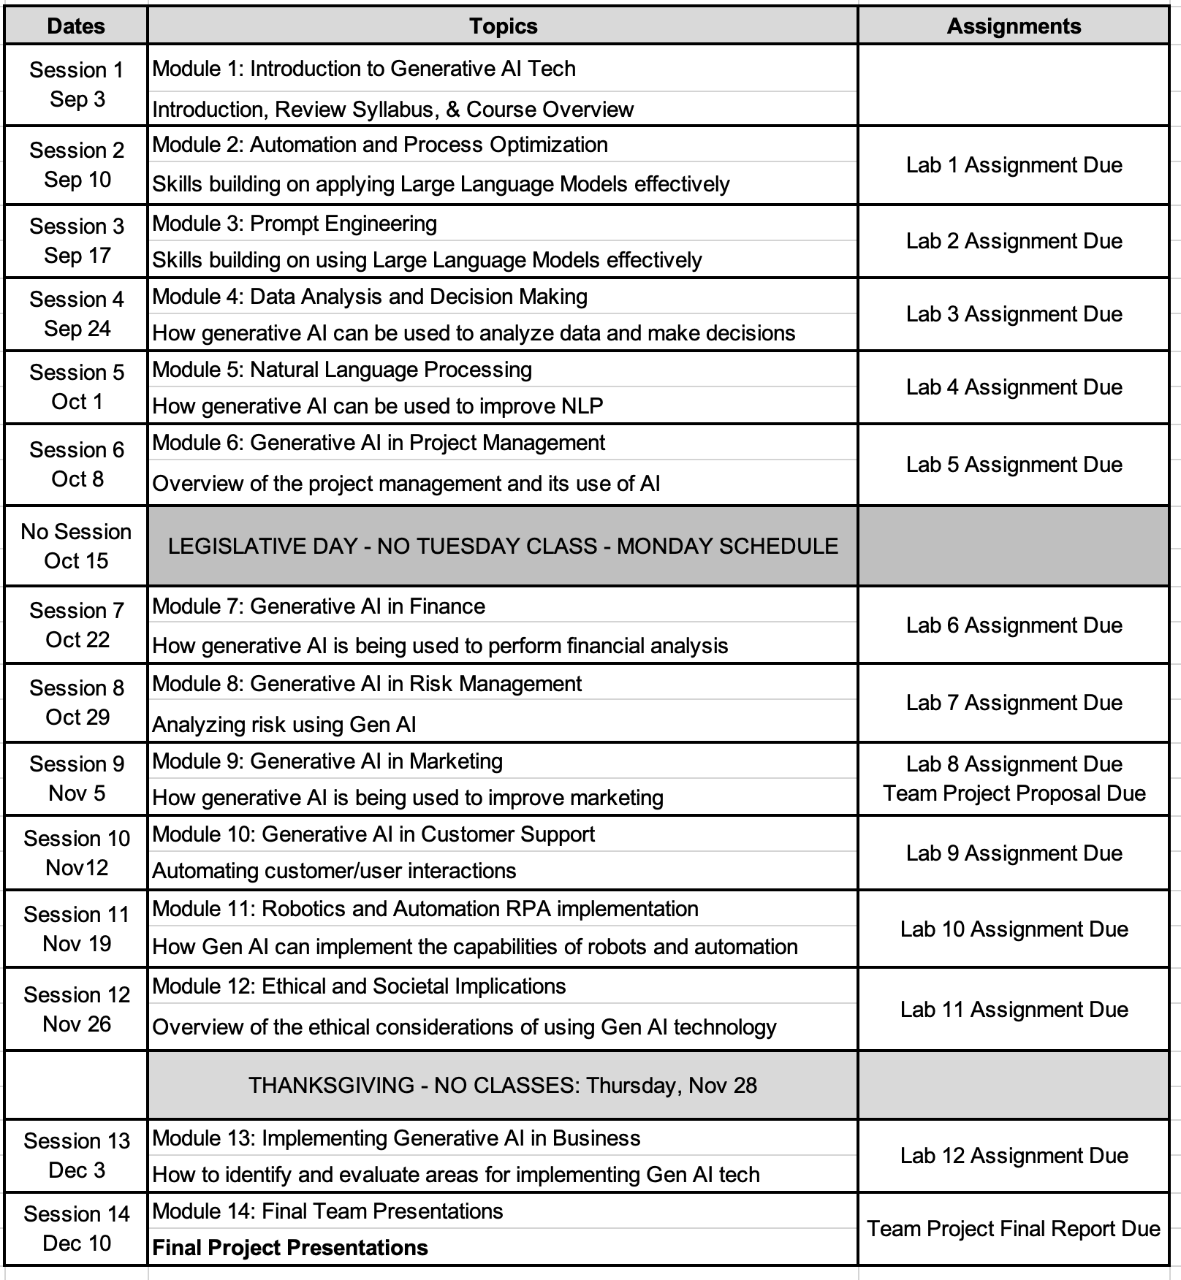**Class Schedule Summary**

**NOTES:**

The syllabus may be modified to better meet the needs of students and to achieve the learning outcomes.

The School of Professional Studies (SPS) and its faculty celebrate and are committed to inclusion, diversity, belonging, equity, and accessibility (IDBEA), and seek to embody the IDBEA values. The School of Professional Studies (SPS), its faculty, staff, and students are committed to creating a mutually respectful and safe environment (*from the* [*SPS IDBEA Committee*](https://www.sps.nyu.edu/homepage/about-us/idbea/about-idbea.html)).

**New York University School of Professional Studies Policies**

1. Policies - You are responsible for reading, understanding, and complying with [University Policies and Guidelines](http://www.nyu.edu/about/policies-guidelines-compliance.html), [NYU SPS Policies and Procedures](http://sps.nyu.edu/academics/academic-policies-and-procedures.html), and [Student Affairs and Reporting](https://www.nyu.edu/about/policies-guidelines-compliance/policies-and-guidelines/student-services.html).

2. Learning/Academic Accommodations - New York University is committed to providing equal educational opportunity and participation for students who disclose their dis/ability to the [Moses Center for Student Accessibility](https://www.nyu.edu/students/communities-and-groups/student-accessibility.html). If you are interested in applying for academic accommodations, contact the [Moses Center](https://www.nyu.edu/students/communities-and-groups/student-accessibility/academic.html) as early as possible in the semester. If you already receive accommodations through the Moses Center, request your accommodation letters through the [Moses Center Portal](https://www.nyu.edu/students/communities-and-groups/student-accessibility.html) as soon as possible ([mosescsa@nyu.edu](mailto:mosescsa@nyu.edu) | 212-998-4980).

3. Health and Wellness - To access the University's extensive health and mental health resources, contact the [NYU Wellness Exchange](https://www.nyu.edu/students/health-and-wellness/wellness-exchange.html). You can call its private hotline (212-443-9999), available 24 hours a day, seven days a week, to reach out to a professional who can help to address day-to-day challenges as well as other health-related concerns.

4. Student Support Resources - There are a range of resources at SPS and NYU to support your learning and professional growth. For a complete list of resources and services available to SPS students, visit the [NYU SPS Office of Student Affairs site](https://www.sps.nyu.edu/homepage/student-experience/resources-and-services.html).

5. Religious Observance - As a nonsectarian, inclusive institution, NYU policy permits members of any religious group to absent themselves from classes without penalty when required for compliance with their religious obligations. Refer to the [University Calendar Policy on Religious Holidays](https://www.nyu.edu/about/policies-guidelines-compliance/policies-and-guidelines/university-calendar-policy-on-religious-holidays.html) for the complete policy.

6. Academic Integrity and Plagiarism - You are expected to be honest and ethical in all academic work. Moreover, you are expected to demonstrate how what you have learned incorporates an understanding of the research and expertise of scholars and other appropriate experts; and thus recognizing others' published work or teachings—whether that of authors, lecturers, or one's peers—is a required practice in all academic projects.

Plagiarism involves borrowing or using information from other sources without proper and full credit. You are subject to disciplinary actions for the following offenses which include but are not limited to cheating, plagiarism, forgery or unauthorized use of documents, and false form of identification

[Turnitin](https://www.nyu.edu/servicelink/KB0018471), an originality detection service in NYU Brightspace, may be used in this course to check your work for plagiarism.

Read more about academic integrity policies at the NYU School of Professional Studies on the [Academic Policies for NYU SPS Students](https://www.sps.nyu.edu/homepage/student-experience/policies-and-procedures.html) page.

7. Use of Third-Party Tools - During this class, you may be required to use non-NYU apps/platforms/software as a part of course studies, and thus, will be required to agree to the “Terms of Use” (TOU) associated with such apps/platforms/software.

These services may require you to create an account but you can use a pseudonym (which may not identify you to the public community, but which may still identify you by IP address to the company and companies with whom it shares data).

You should carefully read those terms of use regarding the impact on your privacy rights and intellectual property rights. If you have any questions regarding those terms of use or the impact on the class, you are encouraged to ask the instructor prior to the add/drop deadline.